ITBW21 VISUAL ANALYTICS PROJECT

AY2022

|  |  |  |
| --- | --- | --- |
| **Module Group:** |  | ITBW21-02 |
| **Team Name:** |  | Group 2 |
| **Team Members:**  *(* denotes the team leader)* |  | 1. Darren Wong (*)  2. Gangula Karthik  3. Gabriel Loh  4. Victor Hoan |

Table of Contents

Executive Summary 3

Project Plan 4

Team Structure and Roles 4

Project Timeline 4

Project Tools 6

Data Understanding, Visualization, and Modelling 7

**Economic Environment** 7

**Housing** 12

**Transportation** 19

**Education** 26

Problems Encountered 30

Future Enhancements 31

Conclusion 31

## Executive Summary

#### Documented by Karthik

The aim of our study is to evaluate Singapore as a favorable location for recent university graduates aged 21 to 34, with limited work experience. This demographic is crucial as they represent the upcoming generation of professionals entering the workforce and can provide valuable insights into the job market, career prospects, and overall quality of life in Singapore.

We adopted a structured approach by breaking down the complex problem into smaller, manageable factors - Economic Environment, Housing, Transportation, and Education. This methodology enabled us to deeply analyse and comprehend the impact of each factor on the overall state of Singapore and the implications for our target audience. Through these insights, we identified the strengths, weaknesses, and opportunities within each area.

Utilizing a data-driven approach, our team produced visualizations for each factor to provide a holistic view of Singapore as a location for recent university graduates with limited work experience. This comprehensive evaluation has helped us gain a better understanding of the opportunities and challenges available in Singapore.

From our analysis, it is evident that Singapore has commendable transportation and education systems that are affordable and easily accessible to many individuals. However, the housing and economic environment could be further improved, as not everyone is financially stable enough to protect themselves against rising prices in these areas, particularly recent college graduates who are starting their careers. Nonetheless, we acknowledge that the government is taking proactive measures by providing more grants and subsidies to its citizens.

In summary, our report provides a comprehensive evaluation of Singapore as a location for recent university graduates with limited work experience. By identifying the opportunities and challenges available in the country, we are confident that our findings can inform future decision-making by the target audience.

## Project Plan

#### Documented by Karthik

### Team Structure and Roles

|  |  |  |
| --- | --- | --- |
| **Name** | **Role** | **Factor** |
| Darren Wong | Team Supervisor, communication with stakeholder | Economic Environment |
| Gangula Karthik | Team member, Design and Merging of the reports, Project Planning and Documentation | Housing |
| Gabriel Loh | Team member, Project Documentation | Transportation |
| Victor Hoan | Team member, Project Documentation | Education |

### Project Timeline

Figure 1.1 to 1.3 displays the project timeline, which was developed using ClickUp, a project management tool. The timeline provides a clear overview of the project's progress and schedule. The Project was broken down into 3 phases: Project proposal phase, Data preparation and modelling, Final presentation.

Figure 1.1: Project Proposal Timeline

Figure 1.2: Data Preparation and Modelling Timeline.

Figure 1.3: Final Presentation

### Project Tools

Some of the tools that we have used for the project are included in the table below

|  |  |  |
| --- | --- | --- |
| Tools Used | Purpose | Used by |
|  | This tool is called discord and its use allows us to communicate with one another in real-time through text, voice, and video chats. It also provided us with a platform to share files, links, and other resources necessary for the project. | All members in the group |
|  | we used google drive for collaborative document creation, storage, and sharing, which allowed multiple team members to work on the same document simultaneously and in real-time. | All members in the group |
| ClickUp™ | One app to replace them all | This tool allowed the team to stay organized by easily allowing them to easily manager their projects, tasks and deadlines | All members in the group |
| Postman Merchandise Store – Postman Store | We utilized this tool to test the API before integrating it into Power BI. This helped us to anticipate the type of responses we could expect and to validate that we had accurately entered the API endpoint. | Used by Karthik and Gabriel |
|  | We used this tool for collaborative code writing to perform data collection. | Used by Karthik and Darren |
| What is Power BI? Get started with Power BI: 7 Easy Steps | Power BI was utilized to develop the dashboards | All members in the group |
| Excel Logo, symbol, meaning, history, PNG, brand | Excel was used for data cleaning in instances where the data cleaning process was more intricate and challenging to perform in Power BI. | Used by Darren, Gabriel, and Victor |

## Data Understanding, Visualization, and Modelling

#### Documented by Darren, Karthik, Gabriel, and Victor

### **Economic Environment**

This section is documented by Darren

**Wages and Job Market**

Figure 1.4

Visual Used

1. Multi-row Card
2. Clustered Column Chart

Datasets Used

* Data for monthly basic wage: <https://data.gov.sg/dataset/median-monthly-basic-and-gross-wages-of-common-occupations-by-establishment-size-in-all-industries>

The next visual in the analysis displays the monthly wage of various occupations and industries. This visualization is similar to the earlier retrenchment and re-entry into employment statistics, but it is designed to help target users estimate their potential wages when seeking future employment. The visual includes a basic wage range and occupation filter to enable users to search for their desired job title and corresponding wage range. For instance, a prospective manager can search for all "Manager" jobs to view the wages earned by each managerial position. The basic wage range slicer further allows the user to filter the wage range of interest. The multi-row card included below the visuals provides a quick comparison of each job of interest. Overall, these filters aim to provide users with comprehensive knowledge of the jobs and industries they are interested in working in.

**Household Expenditure Analysis**

Figure 1.5

Visuals Used

1. Decomposition tree
2. Card
3. Table

Datasets Used

* Data on household-expenditure: <https://www.singstat.gov.sg/find-data/search-by-theme/households/household-expenditure/latest-data>

Decomposition tree was chosen as a visual to explain the household expenditure analysis dataset. A decomposition tree is able to give detailed breakdown of the expenditures by category and gives in-depth insight on each individual item’s price as well. By interacting with the tree, target users will be able to expand on each category and adequately assess if they will be budgeting their expenditure for the items that are listed.

**Employment Trends Analysis**

Figure 1.6

Visuals Used

1. Line and Clustered Column Chart
2. Multi-row Cards

Datasets Used

* Data on retrenchment and re-entry into employment: <https://stats.mom.gov.sg/Pages/ReEntryIntoEmploymentTimeSeries.aspx>

The stacked column and line chart is a visual tool that provides valuable insights into the job market for job seekers. By presenting the retrenchment and re-entry into employment statistics across different industries, the chart allows users to understand the impact of layoffs and unemployment in those industries. This information can help job seekers make informed decisions about their job search and assess the demand for their skills in various fields. For instance, industries with a high rate of retrenchment may indicate a scarcity of job prospects, whereas industries with a high rate of re-entry into employment could suggest a demand for workers in that field.

**Statistical Modelling**

Figure 1.7

By using Consumer Price Index and year, a regression model was generated for the total expenditure of all categories of items every year. The goal of this model is to identify the factors that contribute to changes in the Consumer Price Index over time and how they affect it. For example, these factors could be inflation, unemployment, or gross domestic product (GDP). The regression model takes into account these factors and uses them to make predictions about future changes in the Consumer Price Index. The model does this by calculating the strength and direction of the relationship between the Consumer Price Index and each of these factors, based on historical data. The model is able to analyse individual categories of the Consumer Price Index to evaluate the fluctuations in prices for consumer goods over the years.

This regression model for Housing and Utilities has the follow statistics:

1. n: 22 - This refers to the sample size, which is the number of observations used to estimate the regression coefficients. In this case, the regression was estimated using a sample of 22 observations.
2. Corr: 0.71 - This is the correlation coefficient, which measures the strength of the linear relationship between the two variables. A correlation coefficient of 0.71 indicates a strong positive correlation between the variables.
3. R2: 0.51 - This is the coefficient of determination, also known as R-squared, which measures the proportion of the variance in the dependent variable that is explained by the independent variable. An R-squared value of 0.51 means that 51% of the variation in the dependent variable can be explained by the independent variable.

This regression model in figure1.7 for Food Serving Services has the follow statistics:

1. n: 22 - This refers to the sample size, which is the number of observations used to estimate the regression coefficients. In this case, the regression was estimated using a sample of 22 observations.
2. Corr: 0.94 - This is the correlation coefficient, which measures the strength of the linear relationship between the two variables. A correlation coefficient of 0.94 indicates a very strong positive correlation between the variables.
3. R2: 0.88 - This is the coefficient of determination, also known as R-squared, which measures the proportion of the variance in the dependent variable that is explained by the independent variable. An R-squared value of 0.88 means that 88% of the variation in the dependent variable can be explained by the independent variable.

Referring to figure 1.4,

The statistical models used aim to answer the question of whether Singapore is a good place to live/work in. The high correlation for each category of the Consumer Price Index with respect to year indicates that the prices are fairly constant without too violent fluctuations that may catch consumers off guard. As displayed in the Average Household Expenditure chart, a family expects to spend around $4,208.70 a month on household necessities. By integrating the regression model with the basic wage range chart as supporting evidence, this would mean that two partners would be required to earn within the range of $1,500 to $3,000 a month to be able to contribute their part to the household economically. The filtered basic wages chart above shows that there are multiple jobs that target users would be able to take on to fulfil the requirements economically, concluding that Singapore is a good place to work/live in economically.

### **Housing**

This section is documented by Karthik

**Upcoming Public and Private Housing Projects**

Figure 1.8

Figure 1.9

Visuals Used

1. Upcoming Public Housing Projects
   1. Stacked Bar Chart
   2. Card Visuals
2. Upcoming Private Housing Projects
   1. Stacked Bar Chart
   2. Card Visuals
   3. Multi-row Card Visuals

Datasets Used

1. Upcoming Public Housing Projects
   1. The BTO public housing data consists of 2 datasets - BTO_waiting_time_data.csv and BTO_additional_features.csv.
   2. BTO_waiting_time_data.csv: the data for this was gathered by web scraping the site <https://www.btohq.com/bto-top-tracker>
   3. BTO_additional_features.csv: This data contained additional information on each property such as the street name and number of units available and this information was also scraped from the same website.
2. Upcoming Private Housing Projects
   1. The URA website's API (<https://www.ura.gov.sg/maps/api/#private-residential-projects-in-the-pipeline>) was utilized to obtain data on private residential projects, but a significant number of records had null values for the TOP date. To address this issue, a web scraping technique was used to extract the TOP dates from the website <https://esingaporeproperty.sg/property-type/condo-private-new/>and substitute them for the missing values in the dataset.

Limited availability in highly sought-after areas can drive up prices and create competition, leading to longer wait times and difficulties in finding affordable housing. Conversely, projects located in less popular areas with more units can offer shorter wait times and less competition, providing more affordable options for those struggling to find housing in highly sought-after areas.

Recommendation

Users should consider the location and number of units available when buying a home. By assessing the popularity of a location and the number of units available, potential homebuyers can make informed decisions that fit their needs and budget. Choosing a location that is highly sought-after may have benefits such as proximity to amenities and potentially higher resale value, but there may also be higher demand and potentially longer wait times. However, choosing a development with more units in that popular location may offer shorter wait times and potentially more affordable prices compared to developments with fewer units.

**Analysis on Resale Pricing**

Figure 2.0

Figure 2.1

Visuals Used

1. Figure 2.0
   1. Line Chart
   2. Area Chart
2. Figure 2.1
   1. Custom Shape Map of Singapore
      1. Created using a topojson file of planning areas in Singapore

Datasets Used

1. Data.gov.sg housing resale prices - <https://data.gov.sg/dataset/resale-flat-prices>

The upward trend in housing prices, as seen in Figure 2.0, indicates that housing in Singapore may not be as affordable as it once was, potentially impacting individuals' ability to find suitable housing within their budget. However, the ability for users to find housing units within their budget by utilizing Figure 2.1, as well as identifying areas with a high rate of increase in resale prices, can help mitigate the impact of rising housing prices.

Special Features

* Users can right click on a particular location on the map to drill through. This will allow them to learn more about the particular location such as the unit information, nearest amenities, and population age demographics

Recommendations

The charts provided can prove to be an invaluable resource for homebuyers in Singapore, enabling them to not only compare the prices of different housing options across various towns and flat types, but also to identify potentially lucrative investment opportunities by analysing the resale price trends. That being said, while these charts offer valuable insights, it is always advisable to seek out the expert advice of a real estate agent before making significant investment decisions.

**Deep dive on locations in Singapore (drill through page for figure 2.1)**

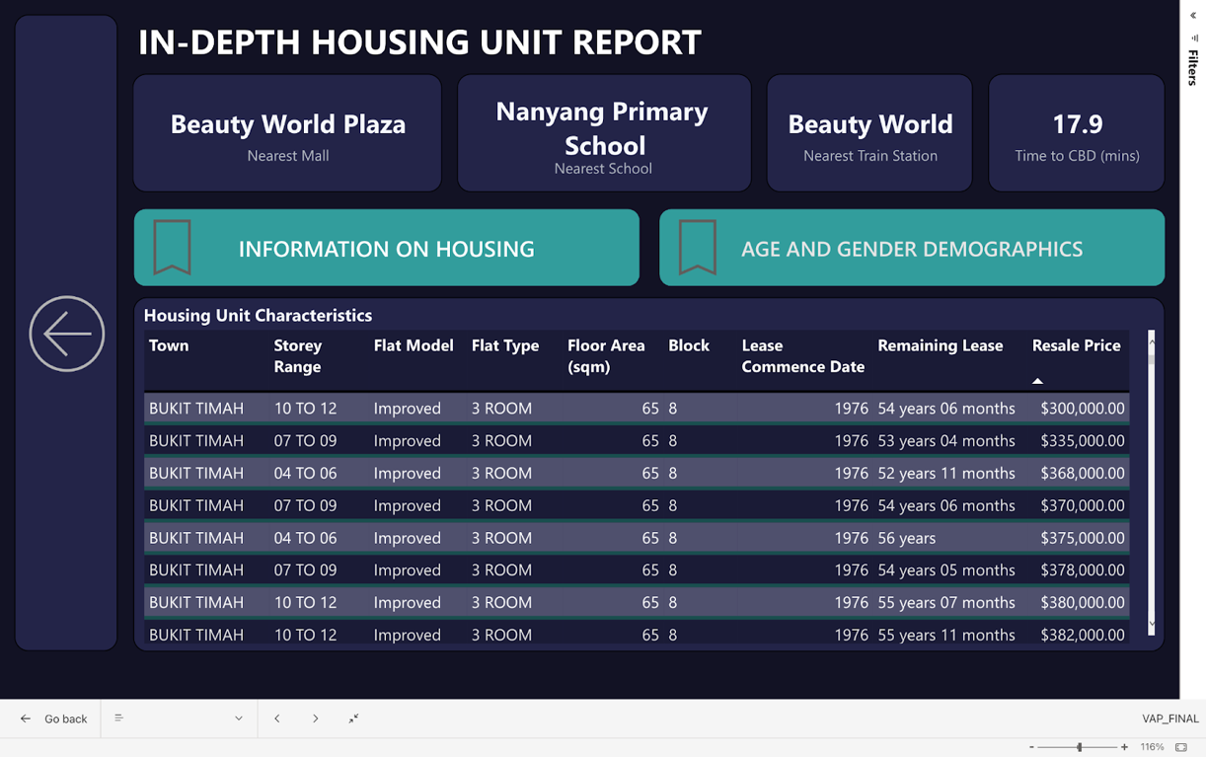

Figure 2.2

Figure 2.3

Visuals Used

1. Table
2. Tree map
3. Card Visuals

Datasets Used

1. We prepared this dataset by first obtaining the coordinates of all housing locations in Singapore using the OneMap search API. We then retrieved data on the nearest primary schools and shopping malls from publicly available sources, such as Wikipedia. For MRT/LRT stations, we obtained a CSV file that already contained their coordinates. After gathering the coordinates, we calculated the shortest distance to each location and added it to each housing entry. This process allowed us to create a comprehensive dataset that includes information on housing prices and the proximity of amenities and transportation options.

a. List of primary schools in Singapore: <https://en.wikipedia.org/wiki/List_of_primary_schools_in_Singapore>

b. List of shopping malls in Singapore:

<https://en.wikipedia.org/wiki/List_of_shopping_malls_in_Singapore>

c. List of MRT/LRT stations in Singapore (with coordinates):

<https://www.kaggle.com/datasets/shengjunlim/singapore-mrt-lrt-stations-with-coordinates>

* 1. OneMap search API: <https://www.onemap.gov.sg/docs/#search>
  2. OneMap Route API(time taken to raffles place MRT): <https://www.onemap.gov.sg/docs/#route>
  3. To obtain age data for a list of planning areas in Singapore, use the OneMap API. First, retrieve the list of planning area names from the Planning Area API (<https://www.onemap.gov.sg/docs/#planning-area>). Then, invoke the Age Data API (<https://www.onemap.gov.sg/docs/#age-data>) with the planning area names column as a parameter to generate the age data for each planning area.

Navigation feature:

Bookmarks were added to navigate between the 2 different charts (table and tree map)

By providing information about factors such as transportation, schools, floor area, lease information, and distance to amenities, users can make more informed decisions about their housing purchases. For example, knowing the nearest MRT station and the time it takes to get to Raffles Place can help individuals determine how convenient their daily commute will be, potentially impacting their overall quality of life. Similarly, information about the nearest primary schools can be crucial for those who are planning to start a family, as it can impact their long-term housing decisions. Details such as floor area, lease information, and distance to amenities can help individuals determine whether a housing unit is suitable for their needs and budget. Lastly, information about the socialization opportunities in a particular area, such as the likelihood of socializing with neighbours of a similar age group, can impact an individual's overall satisfaction with their housing and their sense of community.

**Factors affecting resale prices in Singapore (Statistical modelling)**

Figure 2.4

Visuals Used

1. Key Influencers Chart

By analysing the factors that drive the resale prices for different flat types in Singapore, users can gain a better understanding of how supply and demand affects the housing market, which is a crucial factor in determining the affordability of housing. Understanding the factors that influence resale prices can help individuals make informed decisions about their housing purchases, such as whether to invest in certain flat types or areas. By making more informed decisions, individuals can potentially improve their chances of finding suitable and affordable housing, which can have a significant impact on their overall quality of life.

Statistical Modelling

The purpose of the chart is to identify the key influencers that drive the resale price of 4-room flats, and to provide insights into how these influencers are related to the target variable. The target variable, in this case, is the resale premium, which is the amount by which the resale price of a 4-room flat exceeds its original purchase price.

The most important influencers are storey range, town, and distance to MRT. High storey dwellings have a positive association with the target variable, indicating that the resale premium increases with the height of the flat. Towns such as central area, Queenstown, and Bukit Merah also have a positive impact on the resale price, suggesting that flats located in these towns command a higher resale premium. The proximity to MRT stations also has a positive impact on the resale price, indicating that flats that are closer to MRT stations have a higher resale premium.

Recommendations

Despite the exorbitant housing prices in Singapore, prospective homebuyers can still attain homeownership by making trade-offs such as residing in less popular towns, low storey flats or living further away from mrt stations and shopping malls.

### **Transportation**

This section is documented by Gabriel

**Overview of transportation**

Figure 2.5

Dataset Used

* Statista average number of people taking public transportation - <https://www.statista.com/statistics/1006174/singapore-daily-public-transport-ridership/>
* Kaggle cost of COE - <https://www.kaggle.com/datasets/woonel/singapore-coe-certificate-of-entitlement-prices?resource=download>

Visuals Used

1. Clustered bar chart
2. Line chart

The availability of efficient and reliable public transportation in Singapore makes commuting and moving around the city easier and more convenient, which can positively impact people's lives by reducing stress and increasing productivity. Additionally, the availability of a bike-friendly environment can encourage healthy and active lifestyles, contributing to overall well-being. The lower levels of congestion and pollution resulting from a less car-dependent environment can also improve the quality of life for residents.

Recommendations

* Consider utilizing the public transportation system in Singapore for easier and more convenient commuting and travel within the city.
* Weigh the costs and benefits of owning a car in Singapore, taking into account factors such as the efficiency of the public transportation system.

**MRT performance and cost analysis**

Figure 2.6

Datasets Used

* Travel time and cost between 2 stations: <https://github.com/hxchua/datadoubleconfirm/blob/master/datasets/mrtfaretime.csv>
* List of MRT/LRT stations in Singapore: <https://www.kaggle.com/datasets/shengjunlim/singapore-mrt-lrt-stations-with-coordinates>
* DataMall API: <https://datamall.lta.gov.sg/content/datamall/en/dynamic-data.html>
* Breakdowns and major delays: <https://www.statista.com/statistics/1007813/singapore-mass-rapid-transit-major-delays/>

Visuals Used

1. Map
2. Multi row card
3. KPI

The data on travel time and cost can support the idea that a well-connected public transportation system can improve the quality of life for residents. The information on crowd density can also provide insights into the comfort and congestion levels of public transportation, which can impact people's experiences and satisfaction with their daily commutes.

**Cost versus Distance analysis**

Figure 2.7

Dataset Used

* The dataset, sourced from ptc.gov.sg (<https://www.ptc.gov.sg/fare-regulation/bus-rail/ticket-payment-service-licensing>) comprises of information from over the last few years of the cost of public transport based on the distance as well as the change in cost over time.

Visuals Used

1. Clustered column chart
2. Clustered bar chart

Figure 2.7 provides insights into the affordability of living in Singapore and its relationship to transportation. As the distance travelled increases, the cost of transportation also increases, which suggests that buying a housing unit in a well-connected area may be more cost-effective in the long run. This information supports the overall assessment of whether Singapore is a good place to live in, as it highlights the importance of transportation in making housing more affordable and contributing to a higher quality of life for residents.

**Bus schedule information**

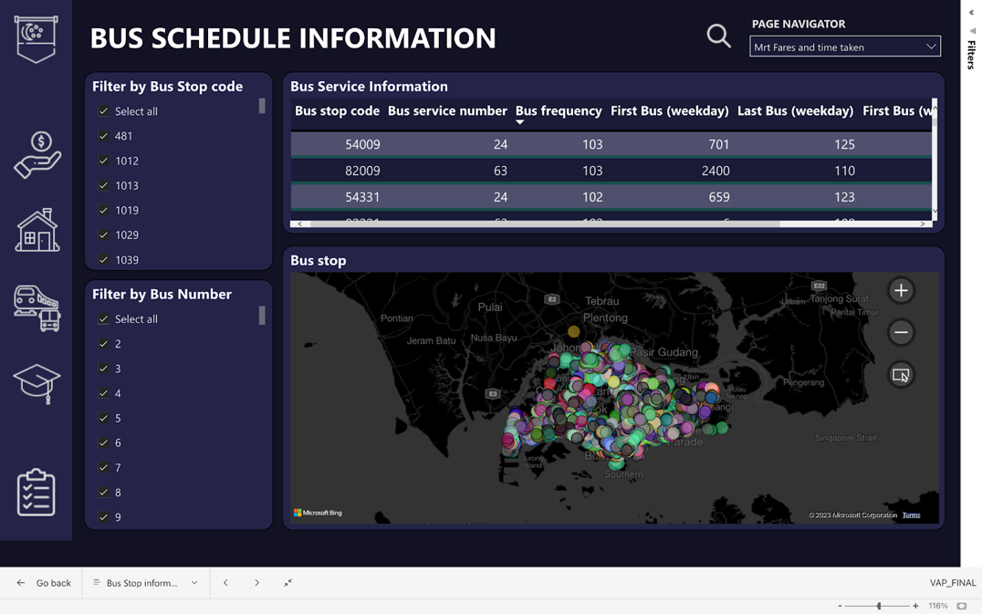

Figure 2.8

Dataset Used:

* Kaggle bus stops location - <https://www.kaggle.com/datasets/gowthamvarma/singapore-bus-data-land-transport-authority?resource=download>

Special Features:

Users can select which bus stop code or bus number they want to view, when the user selects the bus stop code the map will show the exact location of the bus stop.

Visuals Used:

* Table
* Map

The displayed visuals can aid in assessing the accessibility and convenience of public transportation in Singapore, both of which are important factors in determining whether Singapore is a desirable place to live. Specifically, the visuals depict bus stop timings and the corresponding bus routes, providing valuable information for commuters. **Fuel price cost analysis and fuel forecast**

Figure 2.9

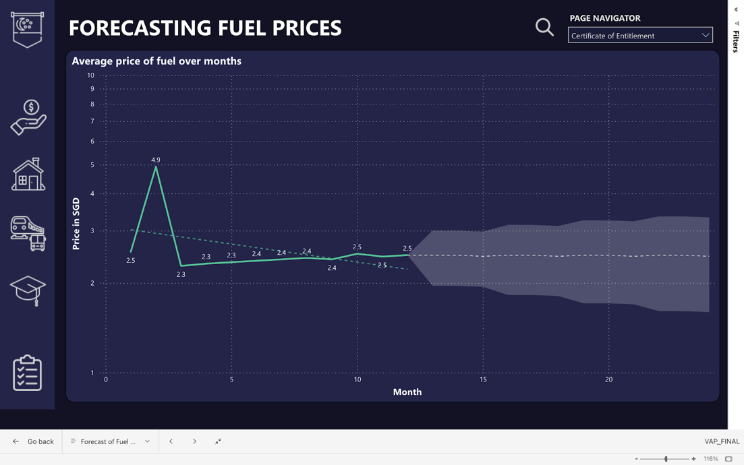

Figure 3.1

Dataset Used:

* Statista monthly gasoline prices - <https://www.statista.com/statistics/1294757/singapore-monthly-gasoline-prices/>
* fueleconomy.gov cost of fuel for cars - <https://fueleconomy.gov/feg/download.shtml>

Visuals Used:

1. Line chart
2. Gauge
3. Table

The cost of gasoline can impact the overall cost of living and the cost of owning a car in Singapore, which could affect someone's decision to live there. Similarly, the estimated cost of fuel for different car models can be a useful factor to consider for those who are looking to purchase a car and live in Singapore.

**Certificate of entitlements analysis and forecast**

Figure 3.2

Figure 3.3

Dataset Used

* Kaggle dataset for COE - <https://www.kaggle.com/datasets/woonel/singapore-coe-certificate-of-entitlement-prices?resource=download>

Features

* + - Users can select the range of year they like to view, and the average per month for the years selected will be shown

Visuals Used

1. Line chart

This dataset is relevant to the hypothesis of whether Singapore is a good place to live in because

 It provides insights into the cost of car ownership in the country. The COE system is used to regulate the number of vehicles on the road, and its cost can have a significant impact on car ownership and usage in Singapore. Knowing the trend and cost of COE can help people make informed decisions about their transportation options, which is an important factor in assessing the liveability of a city.

**Traffic analysis by location**

Figure 3.4

Datasets Used

* + - We prepared this dataset by obtaining the traffic speed band, average lowest and highest speeds, by using the DataMall API.
    - Speed band of all cars on any road:  <https://datamall.lta.gov.sg/content/datamall/en/dynamic-data.html>

Special Features

Users can select any available road from the slicer and the map will show the location of the map while the gauge will show the average minimum and maximum speeds.

Visuals Used

* Route map
* Gauge
* Table

The availability of the dataset on speed bands for all cars on Singapore's roads can offer valuable insights into the traffic conditions and average speeds which can be used to plan travel routes and make informed decisions, potentially reducing the time spent on the roads and contributing to the overall convenience and efficiency of living in Singapore. In this way, this dataset can be a valuable resource for residents and visitors alike, enabling them to make the most of the city's transportation infrastructure.

### **Education**

This section is documented by Victor

**New graduates in the workforce**

Figure 3.5

Datasets Used

* We prepared this dataset by first obtaining the number of graduates by workforce industry. This process allowed us to create a comprehensive dataset that includes information on the number of job vacancies in emerging domain courses that are taken by graduates in 2021.
* It shows the list of short courses on Skills future: <https://go.gov.sg/sdfe2022skillslist>

**Visuals Used:**

* Card Visuals
* Clustered bar chart

The information above provides users with data on short courses that people are seeking from job vacancies in emerging fields on Skills future. The data provided will help graduates get a better chance of obtaining a job, along with gaining the skills they want to add to their skillset that will better improve themselves in the long run, making it easier for them to earn a living by working in Singapore and hence, live a happy life.

**Graduates from different courses**

Figure 3.6

Datasets Used

* List of short courses on Skillsfuture:  <https://go.gov.sg/sdfe2022skillslist>

Visuals Used

* Card Visuals
* Clustered bar chart

The information above provides users with data on short courses that people are seeking from job vacancies in emerging fields on Skills future. The data provided will help graduates get a better chance of obtaining a job, along with gaining the skills they want to add to their skillset that will better improve themselves in the long run, making it easier for them to earn a living by working in Singapore and hence, live a happy life.

**2021 Job postings in emerging fields on skills future**

Figure 3.7

Datasets Used

* List of short courses on Skillsfuture:  <https://go.gov.sg/sdfe2022skillslist>

Visuals Used

* Card Visuals
* Clustered bar chart

Relation to Hypothesis

The information above provides users with data on short courses that people are seeking from job vacancies in emerging fields on Skillsfuture. The data provided will help graduates get a better chance of obtaining a job, along with gaining the skills they want to add to their skillset that will better improve themselves in the long run, making it easier for them to earn a living by working in Singapore and hence, live a happy life.

**Graduates by universities**

Figure 3.8

Dataset Used

* <https://data.gov.sg/dataset/intake-enrolment-and-graduates-by-institutions?resource_id=2264a6ed-51f5-45d6-accb-1a980e32e632>
* Line chart that shows the  trend of the number of graduates from different universities respectively over the years

Visuals Used

* Column chart

With the information above, graduates will get a sensing of the competition they will face against other graduates and hence, make a better informed choice on what career they want to pursue in the workforce

**Trend of graduates over the years**

Figure 3.9

Dataset Used

* <https://data.gov.sg/dataset/intake-enrolment-and-graduates-by-institutions?resource_id=2264a6ed-51f5-45d6-accb-1a980e32e632>

Visuals Used

* Line chart with forecast and trend line

Forecast was used on the graph. After plotting the data, it appears an upward trend with a lot of peaks and valleys is displayed. As the year increases, the number of graduates from universities increases.

Hence, it can be concluded that the number of graduates will continue to increase as the years increase respectively, based on the forecast created that determines possible future graduations in universities.

## Problems Encountered

#### Documented by Karthik, Darren, Gabriel and Victor

|  |  |
| --- | --- |
| **Type** | **Problems Faced** |
| Group | During our project, we faced several challenges that affected our progress and required us to implement innovative solutions. One of the significant problems we encountered was the difficulty in finding people who belonged to our target audience. We needed to gather data on a specific demographic, which proved to be a considerable challenge. We had to leverage our connections on social media platforms such as LinkedIn and Reddit to reach our target audience and collect the data we needed. |
| Darren | I have encountered several challenges when it comes to estimating household expenditure due to its subjective nature. Additionally, while historical data on expenditure can be used to analyse trends for the future, it may not necessarily apply to our current situation in 2023. Furthermore, I have realized that the economy is heavily influenced by external factors beyond our control, which can further complicate predictions and planning. |
| Karthik | One obstacle that I encountered was the need to learn how to use APIs and Python to gather data. I had to invest time and resources into acquiring the necessary skills to collect and analyse data effectively. This required me to learn how to use various programming tools, such as web scraping libraries, data analysis frameworks, and APIs. It took me 6 days to write and gather all the data for the data collection.  The other challenge was that the API token that was used kept getting invalid by the end of the day, to fix this we wrote some M code in the advanced editor to generate the API token daily and pass it into the API that we were getting the data from. It took me 2 days to solve this issue. |
| Gabriel | I faced two challenges:   * understanding how to use the route map to plot precise lines and coordinates, which took four days to solve * integrating the API into Power BI Desktop, which was resolved in less than a week and used successfully. |
| Victor | Initially, I lacked the skills and experience for the Visual Analytics Project. However, by completing the project, I have gained the knowledge and confidence needed to perform visual analysis effectively. |

## Future Enhancements

#### Documented by Karthik

It is important to continually seek ways to improve the accuracy and accessibility of our data analysis. One potential area for improvement is the incorporation of additional countries in our analysis, particularly in regards to housing and economic environments. By expanding our dataset, we can gain a more comprehensive understanding of global trends and insights.

To streamline our data collection process, we can utilize automation tools such as Power Automate to automatically refresh housing datasets retrieved through web scraping. This not only saves time and effort, but also ensures that our data remains up-to-date and reliable. Additionally, developing a mobile app using Power Apps can increase accessibility for users and enhance the overall user experience.

Finally, for improved precision in directions and distance calculations, we can integrate the Google Maps API, which is a paid service. This will not only improve accuracy, but also enhance the overall user experience

## Conclusion

#### Documented by Karthik

In conclusion, despite the slightly higher cost of living in Singapore, the average income is sufficient to cover monthly expenses. However, college graduates with median salaries may face challenges in accessing affordable housing due to high property prices, but with flexibility, suitable homes can still be found. It is important to consider the impact of this on Singapore's overall appeal as a desirable place to live and work. Nonetheless, the city's efficient and affordable transportation system, highly regarded education system, and government subsidies and grants for housing make it an attractive option for many. Additionally, the provision of CDC vouchers by the government enhances the affordability of goods and services for the average person. Taking all these factors into account, it is safe to say that Singapore is a good place to live and work, with accessible and affordable transportation and education systems, and various initiatives in place to help citizens achieve financial stability and improve their quality of life.

y